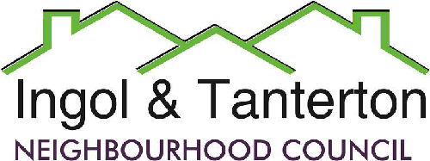

**Agenda**

**A meeting of the Ingol and Tanterton Neighbourhood Council Finance & Asset Committee will be held on Thursday 27th February at 6pm at Tanterton Village Centre.**

**Open forum**

1.To receive apologies.

2.To approve the minutes of the January Finance Committee Meeting.

3.To consider the budget for Ingol Dip and the quotes for extra work.

4. To consider the grant application for an extra £10,000 per year for Intact.

5. To consider the costs for the SpID Solar Panels x 2.

6.To review the budget for 2025/2026.

Press and public are welcome to attend.